National Biosecurity Strategy Annual Report 2025

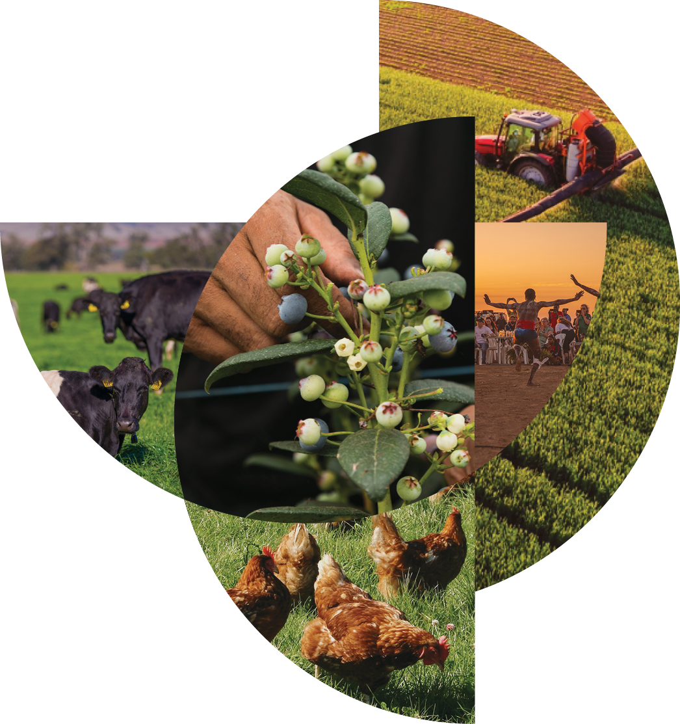
© Commonwealth of Australia 2026
Ownership of intellectual property rights
Unless otherwise noted, copyright (and any other intellectual property rights) in this publication is owned by the Commonwealth of Australia (referred to as the Commonwealth).
Creative Commons licence
All material in this publication is licensed under a Creative Commons Attribution 4.0 International Licence except content supplied by third parties, logos and the Commonwealth Coat of Arms.

Cataloguing data
This publication (and any material sourced from it) should be attributed as: DAFF 2026, National Biosecurity Strategy: Annual Report 2025, Department of Agriculture, Fisheries and Forestry, Canberra, April 2026. CC BY 4.0.
This publication is available at www.biosecurity.gov.au/about/national-biosecurity-committee/nbs
Department of Agriculture, Fisheries and Forestry
GPO Box 858 Canberra ACT 2601
Telephone 1800 900 090
Web agriculture.gov.au
Disclaimer
The Australian Government acting through the Department of Agriculture, Fisheries and Forestry has exercised due care and skill in preparing and compiling the information and data in this publication. Notwithstanding, the Department of Agriculture, Fisheries and Forestry, its employees and advisers disclaim all liability, including liability for negligence and for any loss, damage, injury, expense or cost incurred by any person as a result of accessing, using or relying on any of the information or data in this publication to the maximum extent permitted by law.
Acknowledgements
The authors thank activity leads and collaborators contributing to the implementation of the National Biosecurity Strategy Action Plan and for their support in preparing this report.
Acknowledgement of Country
We acknowledge the continuous connection of First Nations Traditional Owners and Custodians to the lands, seas, and waters of Australia. We recognise their care for and cultivation of Country. We pay respect to Elders past and present, and recognise their knowledge and contribution to the productivity, innovation and sustainability of Australia’s agriculture, fisheries, and forestry industries.

Contents
Introduction and looking ahead 1
Key progress and achievements 3
Appendix A: National Biosecurity Strategy (NBS) Action Plan activity progress 7
Appendix B: Complementary initiatives 20

Tables
Table A1 Priority area 1: Shared biosecurity culture 7
Table A2 Priority area 2: Stronger partnerships 9
Table A3 Priority area 3: Highly skilled workforce 12
Table A4 Priority area 4: Coordinated preparedness and response 14
Table A5 Priority area 5: Sustainable investment 17
Table A6 Priority area 6: Integration supported by technology, research, and data 18
Table B1 Complementary initiatives that align to National Biosecurity Strategy (NBS) priority areas (not exhaustive) 20
Figures
Figure 1 Overall NBS Action Plan activity progress 3
Figure 2 NBS Action Plan activity progress by priority area 3

Introduction and looking ahead
Introduction
The National Biosecurity Strategy (NBS) released in 2022, sets Australia’s long term vision for a stronger and more resilient national biosecurity system, underpinned by the Intergovernmental Agreement on Biosecurity (IGAB). The NBS Action Plan released in December 2024 gives effect to that vision by setting agreed national priorities for delivery, supported by the NBS Implementation Plan which outlines how actions will be progressed and tracked. The NBS Monitoring, Evaluation, Reporting and Improvement (MERI) Framework, which will support implementation evaluation, is due to be released by end-April 2026.
NBS implementation is overseen by the National Biosecurity Committee (NBC), and supported by the NBS Implementation Committee (NIC), which brings together key partners across all levels of government, industry (plant, animal, aquatic), peak representative bodies (farmers, unions, business, logistics and supply chain), environmental, research, and First Nations People to guide delivery across the national biosecurity system.
This inaugural NBS Annual Report presents a consolidated record of progress against NBS priority areas. Specifically, the report provides a progress update on implementation of the NBS Action Plan to December 2025, summarising activities at different stages of delivery (Appendix A) and supporting complementary activities across the national biosecurity system (Appendix B). Information has been compiled from NBS Action Plan activity leads, the NBC and with other reporting mechanisms. This report provides information to support ongoing NBS monitoring and evaluation.
NBS implementation throughout 2025 was strongest in shared biosecurity culture, partnerships, workforce capability, and preparedness and response, with work also progressing on sustainable investment and integration supported by technology, research and data.
National communication and engagement activities increased awareness of biosecurity risks and responsibilities, with initiatives such as the Australian Biosecurity Awards, National Biosecurity Week, National Biosecurity Forum, and the Biosecurity Business Network promoting positive biosecurity behaviours and shared responsibility. Partnerships with First Nations People were strengthened through the Indigenous Ranger Biosecurity Program and associated forums, supporting on-Country surveillance and capability, while international and near neighbour engagement contributed to regional preparedness and shared risk mitigation.
Workforce capability was enhanced through targeted training delivered through the Biosecurity Training Centre and online platforms, improving preparedness, early detection and response across government, industry and environmental biosecurity roles. National readiness was further strengthened through participation in coordinated exercises, progress on livestock traceability, and increased alignment across jurisdictions in managing plant, animal and environmental biosecurity threats.
Collectively, these achievements have improved Australia’s readiness to detect, respond to and recover from biosecurity threats, strengthened coordination across jurisdictions and sectors, and supported more consistent national approaches to biosecurity.

However, NBS implementation has also faced some challenges. Australia’s biosecurity system continues to face increased strategic and operational challenges and risks. For example, growing pressure from increasing global trade and travel, environmental changes, and more frequent and complex pest and disease threats. The latter has resulted in increased frequency, complexity and costs for national biosecurity incursions. These risks are increasingly interconnected across plant, animal, human and environmental health, while supply‑chain volatility and workforce pressures add further strain.
In addition, biosecurity stakeholders (government, industry and broader parties) are faced with cost of living and fiscal pressures, and resourcing constraints.
Given these factors, the capacity and capability needed to progress certain NBS activities has been limited resulting in implementation delays.
Looking ahead
In November 2025, Agriculture Ministers agreed for the NBC to bring forward a national reform agenda to better address key systemic strategic risks and ensure the resilience and sustainability of the system. Given the challenges we all collectively face, there is an opportunity to better prioritise collective efforts on cross-cutting systemic reforms.
The NBS provides a nationally agreed framework to support coordinated national approaches that strengthen partnerships, improve preparedness and response, and support data-driven, science-based decision-making, including through integrated One Health approaches.
Building on progress already made, the NBC, working with governments, industry, First Nations People, environmental and research partners, and other stakeholders, is progressing a future reform agenda that will underpin continued NBS implementation.
Future NBS annual reports will also reflect broader system-wide reporting commitments, including progress on implementation of the 2024 IGAB review recommendations and relevant outcomes of the Inspector-General of Biosecurity’s (IGB) reviews such as the development of an Environmental Biosecurity Status Report and case studies.
Together, these efforts will support a more connected, adaptive and resilient biosecurity system over the life of the NBS.

Key progress and achievements
The NBS Action Plan sets out a collaborative and strategic approach to strengthen Australia’s biosecurity system and includes 52 activities planned for delivery across 2024 to 2026 by the Commonwealth, states and territories, and other biosecurity stakeholders.
NBS Action Plan implementation is well underway with most activities either completed or in progress, as shown in Figure 1.
Figure 1 Overall NBS Action Plan activity progress
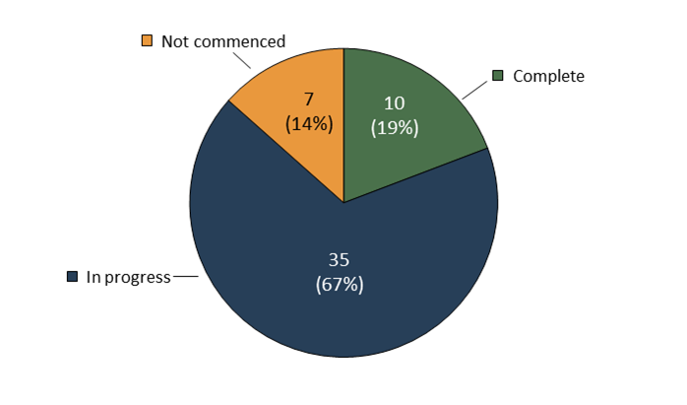
In 2025, delivery was focused on embedding foundational frameworks and early actions that strengthened national coordination, capability and preparedness. Figure 2 shows NBS Action Plan activity progress by priority area.
Figure 2 NBS Action Plan activity progress by priority area
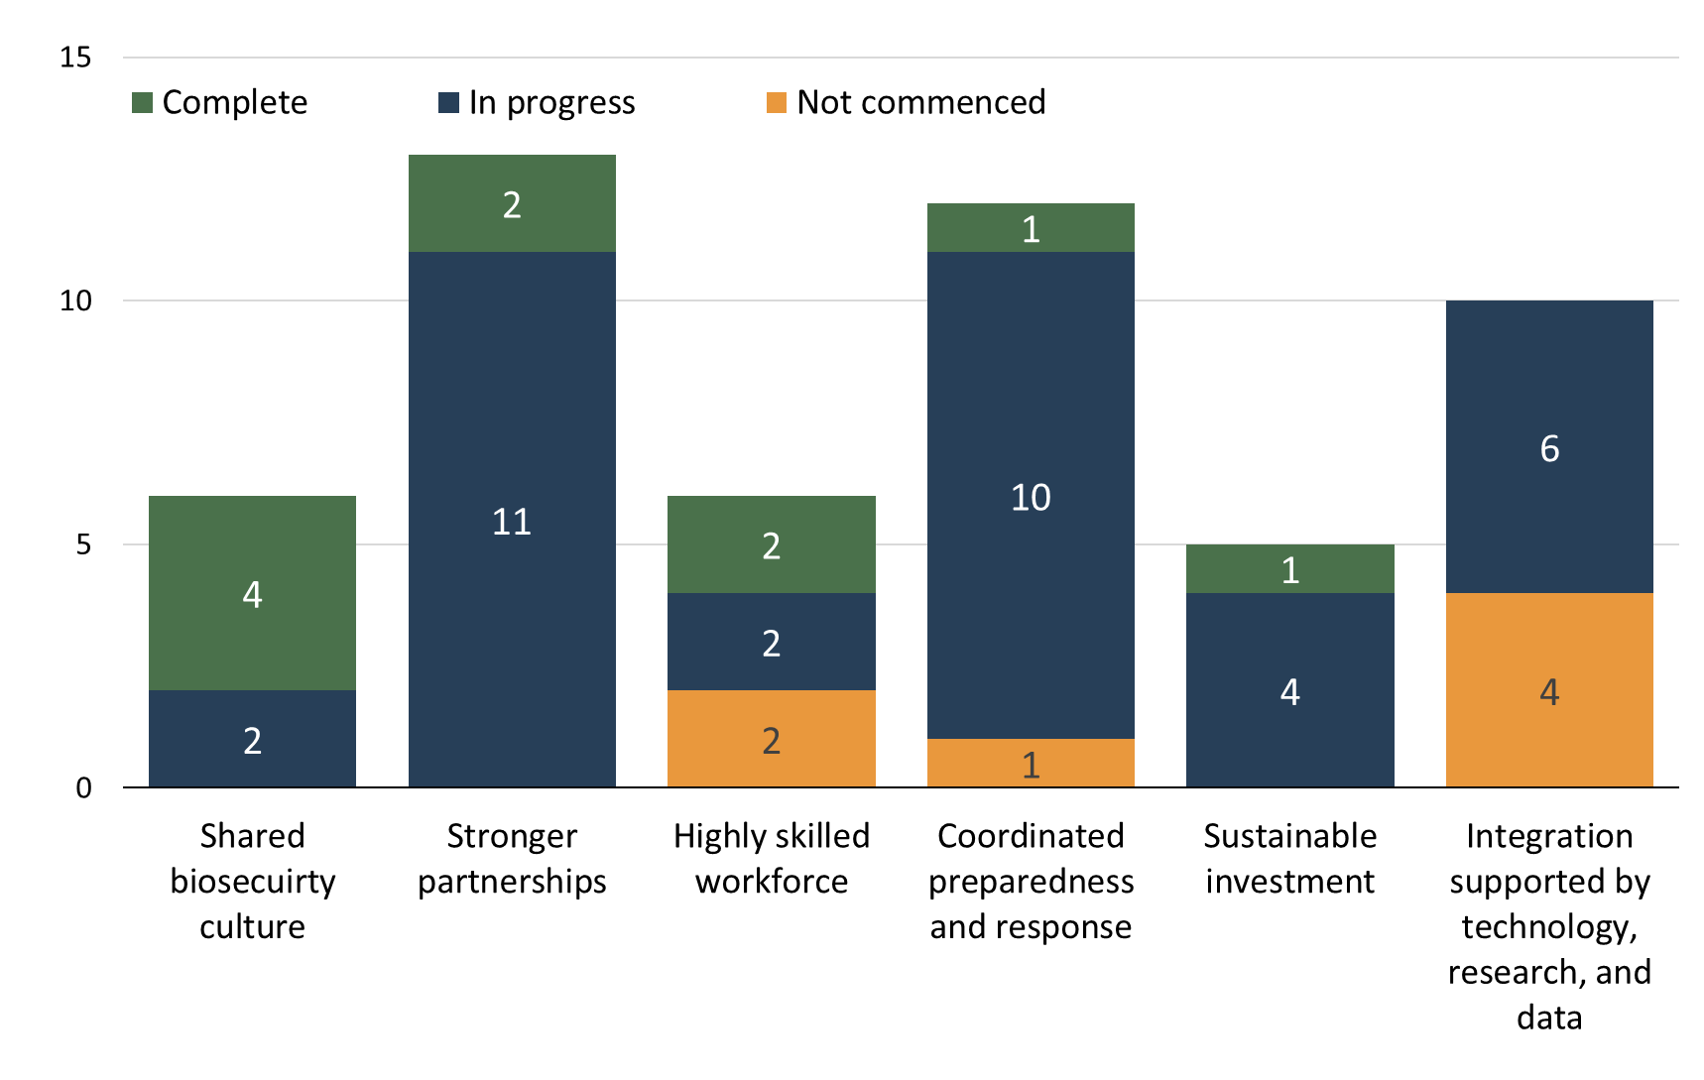

Detailed NBS Action Plan activity reporting, including progress and status, and revised delivery timeframes where applicable, is provided in Appendix A. This reporting is provided by activity leads.
A small number of activities have not yet commenced, reflecting the complex and cross-cutting nature of these activities, or dependencies on the completion of other activities. This includes elements of priority area 3: Highly skilled workforce, priority area 4: Coordinated preparedness and response and priority area 6: Integration supported by technology, research and data. These priority areas and associated reforms are currently being considered by the NBC. Some delivery timeframes have been updated to reflect, for example, dependencies on other activities, strategic prioritisation, and competing national priorities, such as emergency response activities.
The following key achievements were delivered across all six NBS priority areas in 2025.
Priority area 1: Shared biosecurity culture
- Connected stakeholders through the 2025 National Biosecurity Forum (NBF) and National Biosecurity Week.
- Raised awareness of priority biosecurity risks and mitigations through targeted activities and campaigns.
- Supported and incentivised good industry biosecurity practices through the Highly Compliant Importer Scheme and Biosecurity Business Network.
- Revised the National Biosecurity Communication and Engagement Strategy ready for endorsement by the NBC.
- Held the Australian Biosecurity Awards, which recognised 11 recipients across 9 award categories committed to enhancing Australia’s biosecurity system.
Priority area 2: Stronger partnerships
- Held the Environmental Biosecurity Roundtable, which fostered connection, collaboration and strategic discussions.
- Shared Indigenous biosecurity experience and knowledge at the Northern Australia Indigenous Ranger Biosecurity Forum.
- Enhanced collaboration with thirty-five organisations involved in NBS Action Plan activities.
- Surveyed key stakeholders to review, refine and improve national governance roles and responsibilities.
- Strengthened partnerships with our near neighbours and global networks via proactive and lasting engagement.
Priority area 3: Highly skilled workforce
- Commenced a national biosecurity skills review to identify gaps and opportunities for the biosecurity workforce.
- Increased promotion and accessibility of biosecurity-related online training across government and industry through the National Online Biosecurity Training Hub.
- Increased biosecurity awareness in the Torres Strait and Northern Peninsula area through a series of training videos.
- Updated training through the Biosecurity Training Centre for state licenced fumigators, departmental staff and industry participants.
- Increased biosecurity response preparedness through tailored workshops and exercises attended by key stakeholders.
Priority area 4: Coordinated preparedness and response
- Conducted a simulated H5 bird flu scenario through Exercise Convergence, with over 300 participants.
- Aligned the Northern Australian Quarantine Strategy to national priorities while uplifting region specific investments.
- Agreed Australia’s first National Management Agreement to support cost-sharing for a H5 bird flu incursion.
- Improved traceability for sheep, goats, and plants.
- Reviewed traceability governance arrangements.
- Increased uptake of next generation surveillance platforms and technologies across biosecurity sectors.
Priority area 5: Sustainable investment
- Held the national biosecurity sustainable funding and investment workshop, as part of the 2025 NBF, considering funding needs, priorities and sustainable funding approaches.
- NBC agreed to have a coordinated approach to national investments in the biosecurity system, identifying funding needs including capabilities and infrastructure.
- Held the National biosecurity emergency arrangements reform workshop, as part of the 2025 NBF, considering cost sharing arrangements. This covered response, surveillance, and preparedness.
- Published the Biosecurity Funding and Expenditure Report 2024-25, increasing transparency of Commonwealth biosecurity activities, budgeting, and expenditure.
- Commenced a system performance and evaluation framework and continued enhancing the biosecurity value model.
Priority area 6: Integration supported by technology, research and data
- Held the national research and innovation workshop, as part of the 2025 NBF, considering current research activities and to inform future research and innovation priorities.
- Supported the coordination of research activity across governments and industry through existing research programs.
- Supported citizen science initiatives which are a key component of Australia’s biosecurity system, demonstrated through the successful 2025 Khapra beetle response where the initial detection came from a member of the public.
- Continued development of the Australia Biosecurity Research Database (ABRD). This will support biosecurity research by building connections and reducing duplicative efforts.
- Collaborated nationally on innovation with Research and development corporations (RDC’s) and national governance bodies.
There has been significant collaboration and interest in implementing the NBS from across government agencies, industry members, First Nations People and other key stakeholders. This reflects the connection and shared responsibility the strategy aims to achieve.
Beyond NBS Action Plan delivery, biosecurity stakeholders across the system are delivering initiatives which complement the NBS (Appendix B).

Appendix A: National Biosecurity Strategy (NBS) Action Plan activity progress
Tables A1 to A6 summarise and track progress and outcomes against the NBS Action Plan’s 52 activities from 23 December 2024 to 23 December 2025. Hyperlinks in the tables provide further context about an activity or initiative. Delays to delivery timeframes for activities reflect pressures due to competing priorities, funding and resource constraints, and complexities and challenges. Some of the activities reflect Business as Usual (BAU) activities and will be ongoing (even where a key milestone in 2025 was met).
Activity status:
- Complete – The activity has been completed
- In progress – The activity is underway, and progress can be demonstrated
- Not commenced – The activity has not commenced due to prior dependencies, complexities or challenges.

Table A1 Priority area 1: Shared biosecurity culture
Activity | Lead | Status | Progress and outcomes
IA1.1.1 Promote the annual Australian Biosecurity Awards (ABAs) leveraging off stronger partnerships to drive positive biosecurity engagement and spotlight productive initiatives. | Cth | Complete for 2025  Annual  (ongoing) | The 2025 ABAs were held during the National Biosecurity Forum on 5 November 2025.  The ABAs aim to increase awareness of biosecurity: recognising individuals, groups and organisations who have contributed towards safeguarding Australia and showcasing the shared responsibility across industry, government, and the community.
IA1.1.2 Use national biosecurity campaigns to support national biosecurity stakeholders to raise awareness of priority biosecurity risks and mitigations. | Cth | Complete for 2025  Bi-annual (ongoing) | Four national biosecurity awareness activities were delivered during the 2024-25 financial year. These included Hitchhiker awareness, international traveller, H5 bird flu and pork biosecurity. These activities increased awareness of biosecurity risks and mitigations within the community and with targeted stakeholders.
IA1.1.3 Promote the annual National Biosecurity Forum and National Biosecurity Week activities as a vehicle for the dissemination of best practice and focussed attention on innovative and coordinated solutions. | Cth | Complete  Nov 2025 | The National Biosecurity Forum was held from 5 to 7 November 2025. Invited stakeholders shared insights and ideas across a range of NBS priority areas, contributing to a more connected, resilient and shared biosecurity system. The Forum aims to improve collaboration between government, industry, community groups and other stakeholders leading to improved biosecurity outcomes.
 | Plant Health Australia (PHA) | Annual (ongoing) | The 2025 National Biosecurity Week was held from 25 to 31 August . The campaign has organically grown to increase biosecurity awareness and generated widespread support across Australia.
IA1.2 Promote and expand the Highly Compliant Importer Scheme (HCIS). | Cth | Expected  Dec 2026 | In 2025, deliverables included the targeted promotion of the HCIS, website optimisation and expansion of commodities available on the HCIS.  This activity aims to increase awareness, align industry knowledge and utilisation with positive biosecurity behaviours to incentivising compliance. It supports efficient use of resources and reduces regulatory burden while reducing industry costs and rewarding positive behaviours.
IA1.3 Review and augment the National Biosecurity Communication and Engagement Strategy (Strategy) to enhance national communication and engagement and increase real time communication and engagement with stakeholders. | Cth | Due  Dec 2025  Expected  Apr 2026 | In September 2025, the National Biosecurity Committee (NBC) agreed an NBC Communications Plan to inform the Strategy. This was supported by Agriculture Ministers in November 2025.  The Strategy will be published in early 2026, enabling a nationally consistent approach to biosecurity communication and engagement. This will build a stronger biosecurity system by enhancing awareness, understanding and showing how we can work together across government, industry and community. The updated timeframes were to allow time for consultation with key stakeholders to ensure the final document is fit for purpose.
IA1.4 Develop and deliver a Biosecurity Business Network. | Cth  Tas | Complete  Nov 2025 | The Biosecurity Business Pledge Australia was launched on 7 November 2025, as part of the National Biosecurity Forum. The pledge, co-designed with industry, invites businesses to commit to improving their biosecurity practices, helping to protect their business and Australia from pests and diseases. By taking the pledge, businesses will join a Biosecurity Business Network and connect with other business leaders and engage on related topics of interest.  The Biosecurity Business Network will continue to be embedded.

Table A2 Priority area 2: Stronger partnerships
Activity | Lead | Status | Progress and outcomes
IA2.1.1 Continued commitment to the Northern Australia Indigenous Ranger Biosecurity Forum to support biosecurity surveillance and capability building initiatives. | Cth | Complete  Sep 2025 | The Northern Australia Indigenous Ranger Biosecurity Forum was held from 2 to 4 September 2025 in Moungibi, Queensland and hosted by the Carpentaria Land Council Aboriginal Corporation. The event brought together 170 Indigenous Rangers from 45 ranger groups across northern Australia to connect, share experiences and strengthen biosecurity work on Country. The event highlights the vital role Indigenous Rangers perform in protecting Australia from threats of exotic pests and diseases. This was an opportunity for rangers to reconnect with each other and return home inspired, equipped with new ideas and practical skills to strengthen biosecurity in their own regions.
IA2.1.2 Hold an Indigenous Ranger Biosecurity Round Table for continued partnership with ranger groups within the Indigenous Ranger Biosecurity Program to obtain their strategic input and feedback to shape the future direction of the program and improve biosecurity surveillance capability building outcomes. | Cth | Due  Aug 2026  Expected  Sep 2026  Biennial (ongoing) | The planning for the 2026 Northern Australia Indigenous Rangers Biosecurity Round Table is well underway and is expected to be held in September 2026. This will be the third-round table event and builds upon the outcomes of the previous two. This event covers topics including improving and expanding biosecurity activities, future capability building needs, aligning programs with ranger organisation objectives, linking stakeholder activities, economic and employment outcomes. Updated timeframes reflect competing priorities from other events and training planned for 2026.
IA2.1.3 Continued commitment to the Indigenous Ranger Biosecurity Program to support biosecurity surveillance and capability building initiatives. | Cth | Ongoing  BAU | The Indigenous Ranger Biosecurity Program is an ongoing program with sustainable funding which includes fee for service arrangements, capability building, traineeships, and communication and awareness products. This includes, but not limited to, over 600 biosecurity surveillance activities annually, 145 rangers attending biosecurity training and certification courses, and offering capability building grants. The aim to increase biosecurity capability of ranger organisations and economic and employment opportunities for First Nations people. This will lead to earlier detections and increased surveillance of plant, aquatic and animal exotic pests, diseases and weeds across northern Australia.
IA2.2 Review national biosecurity governance arrangements, identifying where roles and responsibilities could be refined to strengthen positive impact, and where real-time consultation can be increased. | Qld. | Due  Jun 2025  Expected Aug 2026 | A survey was designed and responses from relevant key stakeholders have been received, the survey covered aspects of IA2.2, IA.2.3 and IA2.5 to maximise efficiency. Initial progress of this activity was presented at the September 2025 webinar, which supported stakeholder engagement. Responses will be used to generate a report detailing jurisdictional biosecurity governance arrangements, roles and responsibilities and stakeholder involvement in decision-making, including stakeholder views on their efficacy, with recommendations for next steps. The updated timeframes were to allow time for consultation with key stakeholders.
IA2.3 Review of national biosecurity governance arrangements, identifying current stakeholder involvement and where this could be expanded to strengthen positive impact. | Qld. | Due  Jun 2025  Expected Aug 2026 | See IA2.2.
IA2.4 Establish an annual National Environmental Biosecurity Roundtable to bring together key environmental agencies and community groups around priority themes. | Cth | Complete for 2025  Annual (ongoing) | The National Environmental Biosecurity Roundtable was held 11 September 2025 attended by 68 participants across 38 key organisations from environmental agencies, community groups, industry and Commonwealth and jurisdictional governments. All participants found that they were able to connect and network, and 85% thought that the round table met their expectations. The round table successfully raised awareness of the importance of environmental biosecurity with participants interested in attending future round table events.
IA2.5 Review of national biosecurity decision-making bodies, identifying current industry and community involvement and where this could be expanded to strengthen positive impact. | Qld. | Due  Jun 2025  Expected Aug 2026 | See IA2.2.
IA2.6.1 Enhanced near neighbour engagement including deploying a secondee to the FAO Sub-Regional Office for the Pacific Islands and delivering para-veterinary workforce training to Pacific Island nations and Timor-Leste. | Cth | Due  Jun 2025  Expected  Dec 2026 | A 12-month secondment to Timor-Leste facilitated through collaboration between the Timor-Leste government and Department of Foreign Affairs and Trade was completed in 2025. This activity has multiple initiatives to improve the biosecurity capability and partnerships with Australia’s near neighbours in the Pacific. Including the PNG Biosecurity Twinning Program, Rabies management in Timor–Leste and strengthened relationships with Indonesia. Updated timeframes are inclusive of further proactive engagement with a focus on longer term outcomes.
IA2.6.2 Enhance international collaboration through engagement with the Euphresco network to share libraries of reference spectra (fingerprints) and technical approaches for use of MALDI-ToF mass spectrometry to identify bacteria. | Cth | Due  Oct 2026 | This activity will help fill gaps within MALDI-TOF reference databases for plant pathogenic bacteria. Progress has included selection of pathogenic bacterial isolates and coordination of distribution. This activity is progressing through collaboration with 10 organisations, many of which are international research organisations. The outcomes of this project will help refine Australia’s National MALDI-ToF Reference Library Standards. In turn improving Australia’s capability to rapidly identify pathogens, the effectiveness of which depends entirely on the reference libraries.
IA2.6.3 In collaboration with the Pacific Island Countries and Territories, develop a Pacific Strategy for sea containers to minimise the spread of pest risk associated with sea container movements within the Pacific region. | Cth | Due  Sep 2026 | The Pacific Strategy document has been drafted with consultation from the Pacific Plant Protection Organisation (PPPO). Significant stakeholder consultations were undertaken throughout 2025 including several workshops. Outcomes of consultation informed the Pacific Strategy. Finalisation of the strategy is in progress for approval and adoption by the PPPO. This activity aims to reduce biosecurity risks in the region resulting in fewer inspections thus consequent cost saving for industry. It will also deepen partnerships and capacity building in the Pacific region.
IA2.7 Implement measures 1.1, 1.2, 4.1 and 5.3.1 of Australia’s Animal Sector Antimicrobial Resistance Action Plan (AMR Action Plan) 2023 to 2028. | Cth | Due  Jun 2026 | Four projects are underway to assist in understanding the current state of antimicrobial resistance, deliver improvements to current systems, and to understand and mitigate AMR. The following projects are expected to be complete by June 2026:  - A survey of AMR in the dairy industry, co-funded by Dairy Australia.  - Development of prescribing guidelines for the extensive beef cattle sector, led by the Australian Veterinary Association and the industry.  - A risk assessment to guide future design of AMR surveillance in the animal health sector, funded by DAFF and delivered by Commonwealth Scientific and Industrial Research Organisation (CSIRO).  - Development of a business case to support ongoing funding of activities to mitigate AMR in the animal health sector.  These activities will help reduce the likelihood of AMR development through infection prevention in the first place and the appropriate antimicrobial use.
IA2.8.1 Produce a comprehensive forward work plan to document national efforts in biosecurity international engagement. | Cth | Due  Dec 2025  Expected  Mar 2026 | The Biosecurity International Engagement Forward Outlook for 2026 is drafted and being consulted with jurisdictions to help ensure the document is appropriate and fit for purpose. The aim of this activity is to enhance visibility, mutual trust, and greater understanding of biosecurity international engagement between jurisdictions.
IA2.8.2 Develop a National Biosecurity International Engagement Strategy to coordinate efforts and focus on highest priority opportunities. | Cth | Due  Oct 2026 | Planning has commenced for development of a National Biosecurity International Engagement Strategy, which will aim to improve alignment and prioritisation in international engagement, ultimately deepening Australia’s international partnerships and capacity building.

Table A3 Priority area 3: Highly skilled workforce
Activity | Lead | Status | Progress and outcomes
IA3.1 Conduct and disseminate a national biosecurity skill needs analysis to identify current and emerging critical skills gaps opportunities. | NSW  SA | Due  Jun 2025  Expected Jun 2027 | The workforce gap skills analysis is in preliminary stages and project has an expected delivery in June 2027. The skills gap analysis, in consultation with industry, will explore existing and future workforce requirements to aid in identifying current, emerging or future workforce challenges and skills gaps and shortages, and areas of risk.  Outcome of the analysis will inform activities IA3.2 and IA3.3 indicating skills needed develop and sustain workforce capability across the system by ensuring future needs in key areas and building a future ready workforce. Updated timeframes reflect the process of identifying and engaging a suitable delivery partner with national reach.  Early deliverables and insights from the project will be delivered through 2026.
IA3.2 Operationalise the skills needs analysis through a National Biosecurity Workforce Strategy that includes education pathways. | TBC | Due  Oct 2026  Awaiting IA3.1 | This activity is reliant on the completion of IA3.1, as an inherent next step to the outcomes of IA3.1.
IA3.3.1 Institute a specialist stream for biosecurity workforce in the National Biosecurity Forum to build on and expand existing cooperative and partnership arrangements. | TBC | Due  Dec 2025  Awaiting IA3.1 | This activity is reliant on the progression of IA3.1, timeframes updated to reflect its progression.
IA3.3.2 Expand and promote the National Online Biosecurity Training Hub. | PHA | Due  Dec 2025  Expected Aug 2026 | Considerable progress towards the expansion of the National Online Biosecurity Training Hub (the Hub) was made in 2025. The Hub supports capability of the Australian biosecurity sector through the provision of a live and functional online hub with a focus on relevant and contemporary biosecurity training. Promotion of training opportunities through ongoing communication increases awareness and captures a broader audience.  This enhances capability of the biosecurity workforce in early detection, incident response and preparedness - reducing the spread of exotic pests or diseases. Updated timeframes reflect the need to adapt to a rapidly evolving digital landscape.
IA3.4.1 Broaden biosecurity training delivered through the Biosecurity Training Centre (BTC) to cater to those working in industry and environmental biosecurity roles. | Cth | Complete  May 2025 | The BTC partnership between DAFF and Charles Sturt University (CSU) developed online training for fumigating with methyl bromide. The online training package for accredited persons was launched on 1 May 2025 and timed to coincide with the launch of the new Methyl Bromide methodologies.
IA3.4.2 Develop and deliver training in biosecurity response preparedness and capability to support those working in industry and environmental biosecurity roles. | Cth | Complete  Aug 2025 | The BTC in collaboration with the Office of the Chief Veterinary Officer (OCVO) developed and delivered tailored training. The 2-day workshop, delivered in July 2025, covered rapid risk assessment methodologies related to emerging animal health and zoonotic diseases. Attendees included the Human Animal Spillover and Emerging Diseases Scanning (HASEDS) group including animal health officers from the Department of Agriculture, Fisheries and Forestry (DAFF), the Department of Climate Change, Energy, the Environment and Water, and One Health professionals. This aimed at strengthening Australia’s national biosecurity system through building knowledge, skills and capabilities and ensuring emerging threats are responded to swiftly and effectively.  Following the completion of the activity, the BTC in collaboration with the Torres Strait and Northern Australia Quarantine Strategy is developing 7 short biosecurity training videos focusing on biosecurity inspection and awareness and incorporate First Nations perspectives. These will be finalised by June 2026.

Table A4 Priority area 4: Coordinated preparedness and response
Activity | Lead | Status | Progress and outcomes
IA4.1 Co-design a national preparedness exercise and commence workshops to agree on critical national practices. | Cth | Complete  May 2025 | Exercise Convergence, conducted by the National Emergency Management Agency (NEMA) between 26 to 28 May 2025, brought together more than 300 participants from government, industry, emergency services, not-for-profit organisations and communication specialists. DAFF worked with NEMA to co-design a high pathogenicity avian influenza (HPAI) scenario to incorporate into the exercise, enabling the consideration of biosecurity crises within the broader national emergency management architecture. Outcomes included insights into the challenges and opportunities of managing concurrent and compounding crises. The outcomes of which help improve Australia’s ability to respond to and recover from any crisis.
IA4.2 Agree to national biosecurity recovery principles. The recovery principles should align with contemporary recovery best practice in other hazards, be mainstreamed across the national biosecurity system and be effectively communicated. | Cth  WA | Due  Aug 2025  Expected  Dec 2026 | Initial work has been undertaken to agree on the policy paper position for endorsement by the Agriculture Senior Officials’ Committee (AGSOC). This informs the development of an implementation plan that sets out strategy to mainstream and communicate across the national biosecurity system. This activity aims to establish nationally agreed recovery principles that align with contemporary recovery best practice in other hazards. Ensuring that recovery from biosecurity threats is more effective and efficient from a consistent national approach. Updated timeframe reflects ongoing development and iteration of recovery principles linked to best practice.
IA4.3 Co-design a national horizon scanning and fore sighting framework. Using the framework, develop a horizon scanning and fore sighting document to test and validate that it produces meaningful insights which can be used to inform prioritisation decisions. | Cth | Due  Dec 2026 | Initial strategic discussions on the project scope and approach have been undertaken with Department of Primary Industries, Queensland, through the National Biosecurity Communication and Engagement Network. The outcome of this activity aims to provide a consistent and mutually beneficial framework for the Commonwealth and jurisdictions to test and validate how horizon scanning and fore sighting can reduce uncertainty and inform decision making as it relates to threats to the national biosecurity system.
IA4.4.1 See activities under initial actions IA 3.2 and IA3.3, which will provide a foundation for this action. Outcomes of these activities should be considered for extension in a future NBS Action Plan to support IA4.4. | TBC | Due  Oct 2026  Awaiting  IA3.1 | This activity is reliant on the progression of IA3.1, there will be further opportunity expand continuous learning in the biosecurity workforce throughout the progression of IA3.1. Continuous learning should be a key discussion topic for IA3.3.1, with considerations for achievable outputs with impactful outcomes.  Outcomes of these activities will inform future national reforms.
IA4.4.2 Jurisdictions to consider the use of their existing Biosecurity Forums to support continuous learning. | ACT  NSW  NT  QLD  SA  TAS  VIC  WA | Due  Oct 2026  (ongoing)  BAU | - ACT – Biosecurity awareness and education is ongoing and embedded in all ACT Biosecurity Committee meetings and communications.  - NSW – Numerous continuous learning forums, such as webinars, workshops, training and exercises are delivered providing opportunities to engage, build skills, and enhance capacity and capabilities amongst internal and external stakeholders. It is embedded in BAU activities and exercises are undertaken collaboratively with other agencies.  - NT – Engaging annually with NT Cattlemen’s Association (NTCA) regarding biosecurity at their March conference and biannually with the NT Farmers Association (NTFA) April NTFA conference.  - QLD – Queensland is delivering a stakeholder-focused biosecurity engagement and capability-building program in 2026. This includes nine Biosecurity Response Readiness Workshops and three local government-based exercises across Queensland regions, building preparedness and laying a foundation for key themes to be explored during three Regional Partners’ Fora. A youth-focused biosecurity event will also be held, while the Queensland Biosecurity Partners’ Forum in Brisbane will showcase best practices, innovation, and emerging risks. The Biosecurity Ambassadors Program will further promote collaboration and raise the profile of good biosecurity practices across the biosecurity system.  - SA – Engaging through various forums and programs including supporting primary producers impacted by biosecurity events though the Family and Business (FaB) Mentors service.  - TAS – Biosecurity Tasmania has implemented biosecurity software for use by internal staff and external parties to assist in emergency response, case management and workflow management. This will enhance biosecurity surveillance and understanding while providing a continuous learning mechanism that is built into Biosecurity Tasmania.  - VIC – Compiling an extensive list of current activities with an aspect of biosecurity or opportunity to embed further learnings. This includes Victoria’s Biosecurity Reference Group workshops developing the Biosecurity Strategy Implementation Plan and planning the 2026 Victorian roundtable. Additionally, this initiative has continued to deliver priority programs under four main themes; Policy and Programs, Communications, Systems, and Workforce and Skills.  - WA – Developing a living document of existing forums which will be monitored and amended as needed throughout the life of the project. Opportunities to embed biosecurity learnings is ongoing with a scheduled mid-year review intended to inform a final report.
IA4.5.1 Strengthen national livestock traceability through the implementation of mandatory individual electronic identification (eID) for sheep and goats. | ACT  NSW  NT  QLD  SA  TAS  VIC  WA | Due  Mar 2025  Expected  March 2027 | The sheep and goat eID National Implementation Plan is a nationwide initiative for individual electronic identification (eID) for sheep and goats. All jurisdictions are responsible for implementation towards the 1 January 2027 goal of all sheep and goats must be fitted with an accredited NLIS eID device before leaving a property, regardless of age.  Currently all jurisdictions require all sheep and farmed goats born on or after 1 January 2025 to be fitted with an accredited NLIS eID device before leaving their property of birth. This activity is broadly supported by relevant industry organisations and strengthens our ability to rapidly and accurately trace potential disease incursions. Updated timeframes reflect the ongoing national delivery as per the sheep and goat eID National Implementation Plan timeline.
IA4.5.2 Conduct an audit of the Australian Agricultural Traceability Alliance and Australian Agricultural Traceability Governance Group (ATTGG) processes to identify opportunities for strengthening traceability arrangements. | Cth | Due  Jan 2025  (ongoing) | The ATTGG processes are still relatively new and require time to properly develop. Thus, a report on their governance functions, rather than a full audit is being considered. This will ensure transparency for approximately 250 ATTGG stakeholders, from producers to value-adding businesses, employees, state and territory governments, retailers, logistics firms and data services providers, and exporters. Updated timeframes reflect the progressive delivery of national traceability functions in sequence.
IA4.5.3 Support the introduction and maintenance of a national horse traceability system in Australia underpinned by movement recording used in conjunction with state and territory Property Identification Code systems. | VIC | Due  Dec 2024  (ongoing) | Traceability activities are considered by the NBC through a holistic assessment of national traceability priorities, considering biosecurity risk, alignment to strategic risks and delivery priorities of key national traceability systems. This holistic assessment and consideration of priorities is ongoing. Updated timeframes reflect NBC ongoing consideration of priorities.
IA4.5.4 Strengthen plant traceability through the establishment of nationally consistent arrangements to identify, locate and provide information about any property used for agricultural plant production. Overseen by the Plant Property Identification (PPID) Governance Committee. | NSW  VIC | Due  Dec 2026 | Initial work is underway to develop and implement a Plant Property Identifiers and PPID Register. This includes the formation of working groups to inform cost benefit analysis and development of annual workplans. This activity aims to create robust traceability and provenance systems which are vital for effective biosecurity and food safety incident management as well as maintaining and growing Australia’s global competitiveness.
IA4.6.1 All jurisdictions and other stakeholders continue to invest in next generation surveillance platforms, including emerging artificial intelligence technologies, that could easily be adapted to surveillance and detection for example, the national grain initiative. Consideration will be given to ensuring the platforms meet international standards and trade requirements and end user needs will be considered in the design principles. A community of practice will support this work. | NSW  CSIRO | Due  Dec 2026 | Several projects are underway to explore and improve detection and surveillance, including multiple RDC funded projects. Improvements to surveillance databases are underway through sequencing of pathogen genomic material and developing streamlined protocols for assays. These projects aim to ensure that Australia remains at the forefront of disease surveillance and maintains a strong biosecurity system that can detect and respond to emerging threats.
IA4.6.2 Advance region-based biosecurity preparedness planning. The Northern Australia Quarantine Strategy is implementing enhanced Emergency Animal Disease surveillance and preparedness activities in collaboration with the 3 Northern Australia jurisdictions and Northern Australia stakeholders. Results of this preliminary work will determine opportunities and next steps for other states. | Cth | Due  Jun 2025  Expected  Mar 2027 | This activity is delivering and maintaining numerous collaborative investments designed to uplift northern Australia’s biosecurity management framework under the Northern Australia Biosecurity Strategy 2030 (NABS), and which aligns to NBS national priorities. This includes NABSNet, multiple capability uplift programs, strengthening shared biosecurity culture, and various projects supporting technology, research and data integration. These projects will improve and uplift northern Australia’s capacity and capability to prepare and respond to biosecurity incursion via northern pathways. Updated timeframes reflect the concurrent delivery approach across multiple projects.
IA4.7 Review the existing national data-sharing system to identify next steps needed to deliver a coordinated and interoperable surveillance data-sharing system. This activity will take into consideration lessons learned from COVID-19 and be tested through national response exercises. | Cth | Due  Oct 2026 | Initial work is underway to review the biosecurity data sharing platforms and protocols within the DAFF. Further consultation is underway to determine the platforms used by jurisdictions and industry. The outcome of the platform review is essential for activities under IA6.3 and IA6.4 to be undertaken effectively and efficiently.

Table A5 Priority area 5: Sustainable investment
Activity | Lead | Status | Progress and outcomes
IA5.1 Conduct a national biosecurity system sustainable funding review to identify funding needs and priorities and to inform additional funding resources and mechanisms, as needed. | Cth | Due  Jun 2025  Expected Jun 2026 | The NBC discussed a coordinated approach to national investments in the biosecurity system, identifying funding needs including capabilities and infrastructure.  A sustainable funding and investment workshop was held in November 2025 at the National Biosecurity Forum. Participants considered biosecurity funding and investment needs, priorities and potential solutions for the long-term sustainability and resilience of the national biosecurity system. Ongoing consultation through 2026 will further refine and develop priorities and potential solutions to support targeted reform of the national biosecurity system.
IA5.2 Establish new national Biosecurity Capability and Investment Forum, with an initial focus on delivering a long-term investment plan. | Cth | Complete  Nov 2025 | The National biosecurity sustainable funding and investment workshop was held in November 2025 at the National Biosecurity Forum. The workshop brought together participants from more than 30 organisations across the Commonwealth, state and territory governments, industry, environmental groups and research sector. It provided an opportunity for collaborative discussion between biosecurity stakeholders about funding needs and priorities, and potential solutions to support long-term investment planning for the national biosecurity system.
IA5.3 Review of national surveillance, preparedness and response cost sharing arrangements and development of a national cost sharing options paper. | Cth | Due Dec 2025  Expected Dec 2026 | A review of national cost sharing arrangements has commenced. The National Biosecurity Forum included workshops that considered potential reform of the existing emergency response cost sharing arrangements and identified potential opportunities for cost sharing across other areas of the national biosecurity system such as surveillance and preparedness. Insights from these workshops will inform the development of national cost sharing options.  Updated timeframes reflect sequencing consideration of cost sharing arrangements with scheduled 5-yearly reviews of emergency response deeds, and ongoing stakeholder consultations.
IA5.4 Develop new public reporting of national biosecurity system funding and expenditure including Commonwealth, states and territories and relevant industry bodies. | Cth | Due  Oct 2026  Annual (ongoing) | The Biosecurity Funding and Expenditure Report 2024-25 was published in October 2025, demonstrating the Commonwealth’s commitment to transparency of biosecurity activities, budgeting, and expenditure. The 2024-25 report includes new analysis of biosecurity expenditure by control stage, progress reporting against the strategic priorities of the DAFF Biosecurity 2030 Roadmap and improved structure to enhance readability and accessibility. The report provides a model for biosecurity funding and expenditure reporting that could be adopted by other biosecurity stakeholders to support national reporting.  Updated timeframes reflect the competing priorities with other investment actions.
IA5.5 Undertake analysis to evaluate the return on investment for biosecurity activities to inform future measures. | Cth | Due  Oct 2026 | Consultation is ongoing to explore options once an appropriate value model has been finalised. Significant progress has been made into the enhancement of the Biosecurity Value Model which continues to improve transparency and insight into biosecurity funding, expenditure and risk–return trade-offs and directly supporting more targeted and defensible investment decisions.

Table A6 Priority area 6: Integration supported by technology, research, and data
Activity | Lead | Status | Progress and outcomes
IA6.1 Leverage the current activities and working groups of governments and industry to better coordinate, understand and promote national investment opportunities in biosecurity research, development, and extension, including automation and digitisation. | Cth | Due  Mar 2025  (ongoing)  BAU | Stakeholders across research, community, industry and government sectors discussed current research activities at the NBF, to inform national research and innovation priorities.  Existing research programs, such as Catalysing Australia’s Biosecurity with the CSIRO and the Centre of Excellence for Biosecurity Risk Analysis, are supporting coordination of research activity across governments and industry. Updated timeframes reflect ongoing coordination and delivery of this activity.
IA6.2 Coordinate and align national investments in biosecurity research, development and extension and incorporate into national governance frameworks where appropriate. | Cth | Due  Jan 2025  (ongoing)  BAU | Stakeholders across research, community, industry and government sectors discussed current and future investments in research at the NBF, to inform national research and innovation priorities. Similar discussions were held with RDC’s and national governance bodies, such as the AGSOC Research and Investment Committee and the NBC, to align on priorities for research and innovation. Updated timeframes reflect the ongoing delivery and incorporation into national governance.
IA6.3.1 Agree on foundational dataset suitable to be shared by Commonwealth and jurisdictions on a bi-annual basis. This data will, in the first instance, be focussed on research and research findings and should build on data that is already available, where appropriate. | Cth | Due  Oct 2026  Awaiting IA4.7 | This activity is reliant on the progression of IA4.7, which will inform the decision-making process on the most appropriate database.
IA6.3.2 Complete viability assessment to determine if there is an existing data-sharing platform which is a suitable platform to share this information publicly (e.g. Biosecurity Commons). | Cth | Due  Dec 2025  Awaiting IA4.7 | This activity is reliant on the progression of IA4.7, which will inform the assessment of existing systems.
IA6.4.1 Develop a cross-jurisdiction data-sharing framework primarily focussed on sharing of surveillance and interception data between NBS signatories. | Cth | Due  Jun 2025  Awaiting IA4.7 | This activity is reliant on the progression of IA4.7, which will inform the development of an appropriate and applicable framework.
IA6.4.2 Complete viability assessment to determine if there is an existing data-sharing platform which is a suitable platform to share this information publicly (e.g. AUSPestCheck®, Biosecurity Commons). | Cth | Due  Dec 2025  Awaiting IA4.7 | This activity is reliant on the progression of IA4.7, which will inform the assessment of existing systems.
IA6.5 Implement a collaborative and nationally inclusive approach to fund innovative projects and ideas to strengthen our biosecurity system. Report regularly on innovation projects being delivered and share findings. | Cth | Due  Dec 2024  (ongoing)  BAU | Agile, commercial-style approaches to innovation that accelerate usability and scale were priorities discussed with research and government stakeholders at the NBF, to inform national research and innovation priorities. RDC’s and national governance bodies, such as the AGSOC Research and Investment Committee and the NBC, discussed opportunities to collaborate nationally on innovation projects. Updated timeframes reflect the ongoing delivery of this activity.
IA6.6 Leverage the industry, community and government initiatives to support the uptake of emerging technologies, systems and processes. | Cth | Due  Dec 2024  (ongoing) BAU | Technology transformation and effective implementation pathways were priorities discussed with research and government stakeholders at the NBF, to inform national research and innovation priorities. Recent innovation projects have drawn in national and industry interests, like the 'Global innovation challenge to save honey bees'. Supporting the uptake emerging technologies such as these strengthens Australia’s biosecurity system through innovation. Updated timeframes reflect the ongoing delivery of this activity.
IA6.7 Government, researchers, community, and other relevant entities to increase and promote citizen science initiatives and actively engage local government. This will broaden data collection and bring local expertise and experience to identifying change and anomalies in the landscape. | NBC via Environment and Invasives Committee | Due  Jun 2025  (ongoing)  BAU | Consultation is ongoing to determine an appropriate approach to this activity. Citizen science initiatives are continuously underway and are invaluable to Australia’s biosecurity system. Some initiatives include contributing to the One Million Acts of Science and the Australian Bug Hunt project.  The outcome of this activity aims to improve Australia’s biosecurity system through awareness and understanding. The importance of which was demonstrated from the successful 2025 Khapra beetle response where initial detection came from a member of public. Updated timeframes reflect the ongoing delivery of this activity and the long-term commitment to the role citizen science plays in Australia’s biosecurity system.
IA6.8 Implement a new ABRD to collate and promote biosecurity research and development investments. | Cth | Due  Mar 2025  Expected Jun 2026 | The ABRD is currently in development. The database will collate biosecurity research project information and make this available in a readily accessible format​ to support decisions on future research investments, help identify gaps in biosecurity research and reduce duplication of research effort. Updated timeframes reflect the process of engaging a suitable delivery partner.

Appendix B: Complementary initiatives
Table B1 Complementary initiatives that align to National Biosecurity Strategy (NBS) priority areas (not exhaustive)
Organisation | Priority Area (PA) | Initiative
Animal Health Australia (AHA) | All | AHA Strategic Plan 2025-2030
Animal Health Australia (AHA) | All | Animal Biosecurity Research, Development and Extension Strategy 2023-2028
Agriculture Victoria | PA1  PA4  PA6 | Joint government, industry, research and development and community area freedom surveillance program for Tomato Potato Psyllid (TPP) and CLsO (Zebra Chip)
Agriculture Victoria | PA4 | Forums to support continuous learning - Victoria's Biosecurity Reference Group BRG) comprising 15 independent industry, community and First Nations members holding various roles across farming, aquaculture, not-for-profit, environment, Traditional Owners and other organisations
Agriculture Victoria | PA6 | Development and roll out nationally of Trapbase 7 - the agreed national data capturing platform
City and Environment Directorate, ACT | PA4 | National Plant Health Surveillance Program
Commonwealth Scientific and Industrial Research Organisation | PA4 | Australia’s Centre for Disease Preparedness high containment laboratory identified new virus in Australian flying foxes, strengthening preparedness against emerging infections disease
Department of Agriculture, Fisheries and Forestry (DAFF) | All | DAFF Biosecurity 2030 Roadmap
Department of Agriculture, Fisheries and Forestry (DAFF) | All | PNG Biosecurity Twinning Program
Department of Agriculture, Fisheries and Forestry (DAFF) | PA2 | Pacific Week of Agriculture 2025 – Tonga; Strengthening relationships with Pacific neighbours
Department of Agriculture, Fisheries and Forestry (DAFF) | PA2 | Coordinate international advocacy to help shape global standards, rules and conditions
Department of Agriculture, Fisheries and Forestry (DAFF) | PA3 | Establish National Veterinary Workforce Data and Governance Taskforce
Department of Agriculture, Fisheries and Forestry (DAFF) | PA3 | Northern Australia Roundtable October 2025 bringing together northern animal health stakeholders, identified shared risks, priorities, capability and needs, collaboration and strengthen connections
Department of Agriculture, Fisheries and Forestry (DAFF) | PA2 | Memorandum of Understanding between Indonesian Quarantine Authority and DAFF
Department of Agriculture, Fisheries and Forestry (DAFF) | PA4 | Rabies risk and communication and community engagement strategy
Department of Agriculture, Fisheries and Forestry (DAFF) | PA4 | National Strategic Plan for Rabies Management – Timor Leste, Indonesia
Department of Agriculture, Fisheries and Forestry (DAFF) | All | Biosecurity Plan for Cotton Industry, in collaboration with Cotton Industry, government and other industry
Department of Agriculture and Fisheries, Northern Territory | PA4 | Exercise Raintree – Northern Territory, Western Australia and Queensland conducted a exercise focusing on enhancing capacity and strengthen preparedness and response capability for managing emergency animal disease incursions in northern Australian including Foot and Mouth Disease, and Lumpy Skin Disease
Department of Energy, Environment and Climate Action Victoria | PA5 | Agriculture Victoria Great Biosecurity Quest Trapping Program – citizen trapping program
 | All | Victoria’s Biosecurity Roundtable
Department of Natural Resources and Environment Tasmania | All | Tasmanian Biosecurity Policy
Department of Natural Resources and Environment Tasmania | PA1 | Tasmanian Biosecurity Awards
Department of Natural Resources and Environment Tasmania | PA1 | Tasmanian Biosecurity Basics Campaign
Department of Natural Resources and Environment Tasmania | PA2 | Tasmanian industry and government taskforces including Varroa Mite and Tasmanian Fruit Fly
Department of Natural Resources and Environment Tasmania | PA2 | Biosecurity Grants program – TasFarmers; FruitGrowersTas
Department of Natural Resources and Environment Tasmania | PA4 | Preparedness and Response exercises
Department of Natural Resources and Environment Tasmania | PA4 | Developed and pilot horse traceability app, the Equine Registration and Traceability (ERT) System Tasmania
Department of Natural Resources and Environment Tasmania | PA4 | Tasmanian Traceability project – covering National Livestock Identification System, Property Identification Code, and individual electronic identification for sheep and goats
Department of Primary Industries and Regional Development, New South Wales | All | New South Wales Biosecurity Action Plan 2025 - 2026
 | PA1  PA4  PA6 | Biosecurity Trakka project, NSW leading on behalf of all states, co-designed with plant RDCs provides a centralised platform to help revolutionise plant biosecurity diagnostics in Australia
Department of Primary Industries, Queensland | All | Queensland Biosecurity Strategy 2024 - 2029
Department of Primary Industries, Queensland | All | Queensland Invasive Plants and Animals Strategy 2025-2030
Department of Primary Industries, Queensland | PA1  PA2 | Biosecurity in the Boardroom initiative – collaboration with Qld Farmers Federation to raise awareness of biosecurity risks to businesses and driven engagement across the corporate sector
Department of Primary Industries, Queensland | PA1  PA2 | Queensland Biosecurity Ambassador program
Department of Primary Industries, Queensland | PA2 | Youth Biosecurity Training Hub launched June 2025 in partnership with Plant Health Australia
Department of Primary Industries, Queensland | PA4 | Queensland Invasive Plants and Animals Strategy 2025-2030
Department of Primary Industries, Queensland | PA4  PA6 | Queensland Biosecurity Environmental Scan -Biosecurity Queensland engaged Griffith University in late 2024 to conduct an Environmental Scan to identify some of the key sociocultural factors that drive biosecurity risks in Queensland
Department of Primary Industries, Queensland | PA5 | Queensland Biosecurity Boost Grants program
Department of Primary Industries and Regions, South Australia | PA1  PA4 | South Australian Livestock Biosecurity Blueprint 2030
 | All | South Australia’s Biosecurity Policy 2024-25
Environment and Invasive Weeds Committee (EIC) | PA1  PA5 | National Weed Biocontrol Investment Report was endorsed by the EIC, and agencies have begun to collaborate and invest
Environment and Invasive Weeds Committee (EIC) | PA All | Recognition of long-term, continuous management to reduce the $25B impact of pests and weeds each year on the Australian economy and environment
Environment and Invasive Weeds Committee (EIC) | PA All | Collaboration on national eradication responses including National Tropical Weeds and Red Imported Fire ants
Environment and Invasive Weeds Committee (EIC) | PA All | Cross jurisdictional collaboration in programs and information sharing, including workshops and webinars
Environment and Invasive Weeds Committee (EIC) | PA All | Development and review of codes of practice and standard procedures for prevention, eradication, containment, and control
Environment and Invasive Weeds Committee (EIC) | PA All | Enhance technologies including eDNA, FeralScan and remote sensing to improve detections, and expand surveillance
Environment and Invasive Weeds Committee (EIC) | PA All | National coordination on pest animals - annual updates from national coordinators on feral deer, feral pigs, feral cats/foxes
Grains Research and Development Corporation (GRDC) | PA4  PA6 | GRDC in partnership with government invest in technological processes to improve rapid detection & diagnosis of exotic pests and plant disease which pose a risk to the grains industry
NABS | PA4 | NABSNet Annual Masterclass – Townsville 2025
NABS | PA4 | NABSnet newsletter – Lumpy Skin Disease surveillance strategy, livestock disease surveillance for vets, private practitioners, government and pathologists
NABS | PA3 | NABSnet Significant Disease Investigation Subsidy (SDI) – jurisdictional reporting for exclusions exotic and notifiable disease
NABS | PA3 | Roundtable – included Recovery for Biosecurity, Engaging with Indigenous Communities for Biosecurity, Industry Panel sessions
NABS | PA6 | Literature review on current and future risks of Plant Parasitic Nematodes in Northern Australia in collaboration with Charles Darwin University
NSW National Parks and Wildlife Service | PA1  PA4 | Feral Animal Management Strategy
NSW National Parks and Wildlife Service | PA1  PA4 | Weed Management Strategy
Plant Biosecurity Research Initiative | All | Plant Biosecurity Research Initiative Strategy 2023-2028
Plant Health Australia (PHA) | All | National Plant Biosecurity Strategy and associated preparedness, diagnostics and surveillance sub strategies and implementation plans 2021-2031
Plant Health Australia (PHA) | PA1  PA2  PA4  PA6 | PHA Strategic Plan 2022-2027
Plant Health Australia (PHA) | PA4 | National Action Plan for Pests of Trees and Timber
University of Tasmania | PA2  PA4 | Appointment of Biosecurity Engagement Lead for the Tasmanian Institute of Agriculture (TIA) and Tas Farm Innovation Hub

