National Biosecurity Strategy: Monitoring, Evaluation, Reporting and Improvement Framework


2022-2032
© Commonwealth of Australia 2026
Ownership of intellectual property rights
Unless otherwise noted, copyright (and any other intellectual property rights) in this publication is owned by the Commonwealth of Australia (referred to as the Commonwealth).
Creative Commons licence
All material in this publication is licensed under a Creative Commons Attribution 4.0 International Licence except content supplied by third parties, logos and the Commonwealth Coat of Arms.

Cataloguing data
This publication (and any material sourced from it) should be attributed as: DAFF 2026, National Biosecurity Strategy: Monitoring, Evaluation, Reporting and Improvement Framework, Department of Agriculture, Fisheries and Forestry, Canberra. CC BY 4.0.
This publication is available at biosecurity.gov.au/about/national-biosecurity-committee/nbs.
Department of Agriculture, Fisheries and Forestry
GPO Box 858 Canberra ACT 2601
Telephone 1800 900 090
Web agriculture.gov.au
Disclaimer
The Australian Government acting through the Department of Agriculture, Fisheries and Forestry has exercised due care and skill in preparing and compiling the information and data in this publication. Notwithstanding, the Department of Agriculture, Fisheries and Forestry, its employees and advisers disclaim all liability, including liability for negligence and for any loss, damage, injury, expense or cost incurred by any person as a result of accessing, using or relying on any of the information or data in this publication to the maximum extent permitted by law.
Acknowledgement of Country
We acknowledge the continuous connection of First Nations Traditional Owners and Custodians to the lands, seas and waters of Australia. We recognise their care for and cultivation of Country. We pay respect to Elders past and present, and recognise their knowledge and contribution to the productivity, innovation and sustainability of Australia’s agriculture, fisheries and forestry industries.

Contents
National Biosecurity Strategy: Monitoring, Evaluation, Reporting and Improvement Framework i
Introduction and purpose 1
Approach 2
Monitoring and evaluation principles 2
Framework elements 3
Monitoring 3
Evaluation 4
Reporting 5
Improvement 5
Appendix A: Program logic 6
Appendix B: Key evaluation questions 8
Appendix C: Challenges and limitations 10

Tables
Table A1 Program logic – key outcomes and outputs 6
Table A2 Program logic – inputs, assumptions, external factors and risks 7
Table B1 Key Evaluation Questions 8

Introduction and purpose
The National Biosecurity Strategy (NBS) sets a 10-year roadmap to strengthen Australia’s biosecurity system and provides a shared vision to guide nationwide priorities, planning, and investment. To achieve this vision, the NBS identifies 6 priority areas: Shared biosecurity culture; Stronger partnerships; Highly skilled workforce; Coordinated preparedness and response; Sustainable investment; and Integration supported by technology, research and data. These priority areas are supported by 36 initial actions which were developed in collaboration with stakeholders.
The NBS is supported by the National Biosecurity Strategy Implementation Plan (Implementation Plan), released in early 2024, and the inaugural National Biosecurity Strategy Action Plan (Action Plan) launched in late 2024. Since that time, this National Biosecurity Strategy: Monitoring, Evaluation, Reporting and Improvement Framework (MERI) has been developed in collaboration with members of the NBS Implementation Committee (NIC) and endorsed by the National Biosecurity Committee (NBC).
The NBC is the decision-making body that provides strategic leadership for NBS implementation and reports progress to senior officials and ministers. The NIC supports the NBC by guiding implementation and offering strategic advice from a broad network of biosecurity stakeholders.
The MERI Framework outlines an approach to monitoring and evaluating the effectiveness of the NBS, including progress towards the 6 priority areas and implementation of the 2024 Intergovernmental Agreement on Biosecurity (IGAB) Review recommendations.
Recognising the complexity of Australia’s biosecurity system, this framework adopts a mixed strategy and systems–based approach. The MERI Framework is designed to be flexible and can be adapted to suit the ever evolving global and domestic biosecurity landscape.
The MERI Framework will provide transparency and accountability for implementing the NBS’ shared vision - A biosecurity system that protects Australia and our way of life — connected, resilient, and shared. It will support the NBC and the NIC to understand whether NBS implementation and broader national efforts are contributing to change, and how to build on this foundation.
The Action Plan ceases in December 2026, and the MERI Framework will continue evolve and will be used to inform and finalise a national biosecurity reform agenda that is proposed to deliver on the implementation of the NBS from 2027.

Approach
The MERI Framework includes principles and processes for tracking progress and achievements, assessing impact, and driving continuous improvement. It is intentionally dynamic, designed to adapt over time as priorities shift, data sources improve, and evaluation practices evolve.
The MERI Framework builds on the program logic (Appendix A) and is intended to be a living document that evolves over time, as implementation progresses and data collection and impact measures mature.
The framework is designed to be used alongside other key NBS documents, such as periodic reports and any future reform agendas. It sets out updated monitoring and evaluation (M&E) principles, an outline of activities under the MERI model, key evaluation questions (Appendix B), and challenges and limitations (Appendix C). It also describes the cycle of analysis, reflection, and review to support flexible implementation.
As data availability and evaluation capability improves, NBS monitoring and evaluation capability will mature over time.

Monitoring and evaluation principles
The following guiding principles have been updated from those initially outlined in the Implementation Plan:
- Balance between qualitative and quantitative measures - Consider the balance between qualitative and quantitative measures, having regard to available data, and the need to improve this balance over time as data sources evolve.
- Measurement frequency - Consider the frequency of measurement, and the potential to mitigate resourcing constraints by considering periodic and other measurement points.
- Evolution of the monitoring and evaluation framework - Evolve over time to ensure that it remains in-line with best practice.
- Operationalising the framework - Specify operational arrangements to enable effective and practical implementation of the framework, including iterative improvement over time.
- Minimising data collection burden - Consider the use of existing data where possible to minimise burden, maximise use and avoid duplication.
- Lawful, ethical and culturally appropriate - Undertake due diligence in data collection and sharing to meet legal and policy requirements. It is also important to ensure ethical and culturally appropriate standards are understood and applied when collecting, assessing, using and sharing data, such as upholding Indigenous Data Sovereignty principles.

Framework elements
The elements of the MERI Framework are based on the MERI model which promotes learning and adaptive management in response to progressive monitoring and evaluation. This framework also draws elements from other models including the Monitoring, Evaluation, Learning (MEL) and Benefits, Realisation, Management (BRM) models. This is consistent with the Australian Centre of Evaluation (ACE) principles of evaluation, which highlight the importance of continuous improvement. The relationship between these elements is illustrated at Figure 1.
Figure 1 Relationship between monitoring, evaluation, reporting and improvement
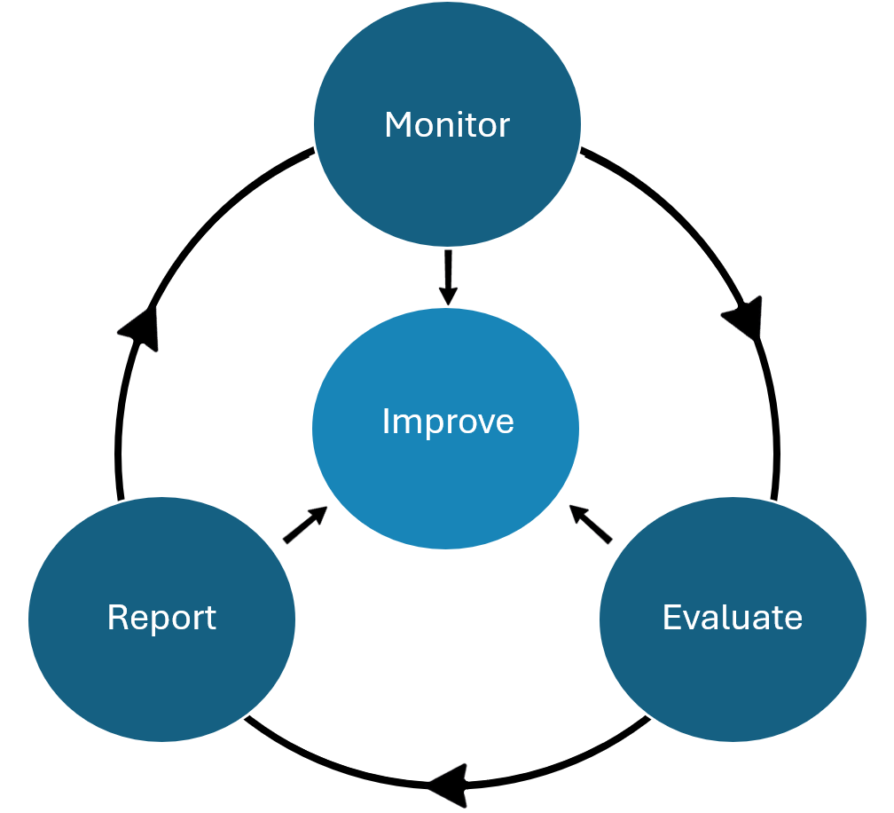
This framework outlines how monitoring, evaluation and reporting supports continuous improvement to deliver the NBS vision and strengthen Australia’s biosecurity system. It also explores how this may look in practice over the life of the NBS.

Monitoring
Monitoring involves the systematic collection of quantitative and qualitative data to track progress, identify issues, and inform decision making.
For the NBS, this may involve the ongoing collection of data and information to track implementation progress, risks, emerging issues, and adjust as needed to ensure success. Monitoring can be used for progress reporting of the Action Plan activities (and future reforms), to inform periodic reporting and reviews, including key evaluation questions (KEQs) (Appendix B). Monitoring activities and associated data collection may broadly include activity implementation data and data to inform periodic reports and reviews.

Activity implementation data
Activity implementation data will be activity (not exhaustive) through:
- Engagement and collection of baseline information from the Action Plan activity leads, leveraging public data sources where relevant.
- Activity progress updates by activity leads, including any relevant information to assist with measuring short, medium or longer term impact and answering KEQs (such as activity adoption or uptake, funding, audience, and risks).
- Meetings of NBS governance bodies and activity leads to discuss insights, progress and issues to inform decision-making, including lessons learned.
- Case studies to highlight milestones and completed deliverables.
- Feedback and insights gathered through surveys, focused workshops and governance meetings, and communications and other engagement activities.
- Media metrics such as website traffic, search engine results, social media engagement.
- Capturing activities that are not included in the action plan but align to the NBS more broadly, to illustrate shared progress and commitment across the biosecurity system.
- Emerging issues, stakeholder priorities and feedback, periodic reflections, public consultations.
- Using the KEQs to guide monitoring and data collection efforts, and determine what we need to collect and measure.

Evaluation
Evaluation involves the systematic and objective assessment of the design, implementation or results of the NBS for the purposes of continuous improvement, accountability and decision-making. It should provide a structured and disciplined analysis of the value of the NBS and its implementation. This aligns with the ACE definition of evaluation.
For the NBS this involves: analysing relevant data to determine whether progress is delivering against intended outcomes of the program logic, including investigating evaluation techniques and data to inform this process. Importantly, evaluation remains adaptive, evolving as the biosecurity risk environment changes and as national reforms progress. Evaluation activities may include ongoing evaluation, and periodic reviews.

Ongoing evaluation
The continuous process of assessment and analysis involves monitoring progress, identifying issues and making timely adjustments as necessary. This could be achieved through ongoing collaboration and engagement with NBS governance bodies and key stakeholders to assess overall effectiveness of implementation efforts, identify system-level impacts, emerging issues, gaps and improvement opportunities. This allows flexibility to incorporate new priorities, emerging risks, and reform-driven changes into evaluation criteria and methods. These activities may include:
- Ongoing informal collection and analysis of relevant data and progress against the action plan/s to assess whether implementation efforts are contributing to program logic outcomes.
- Deep dives or workshops to discuss complex and cross-cutting activities, discuss and resolve identified issues.
- Reflection workshops.
- Canvassing ideas for communications and engagement, periodic reporting, future action planning, and periodic reviews.
- Considering the relationships between various inputs, outputs and outcomes (short, medium and long term) over the life of the NBS (Appendix A).

Periodic reviews
The principle of continuous improvement also recognises the importance of providing sufficient flexibility to adapt strategies and actions if there are changes in the strategic and operating environments for the biosecurity system. The MERI Framework provides a range of tools and resources to help demonstrate NBS effectiveness which can inform periodic reviews.

Reporting
M&E reporting communicates key messages to relevant audiences, supporting transparency, accountability and a shared understanding of performance, challenges and progress. It ensures insights from M&E inform decisions and coordination. Reporting activities may include periodic reporting and implementation progress reporting.

Periodic reporting
- Periodic reports on progress highlight system-wide efforts that advance NBS priority areas. These assist with informing the development of future action plans and periodic reviews.

Implementation progress reporting
- Periodic activity progress updates outline progress, achievements, risks and any required adjustments to improve delivery.
- Case studies may be used to illustrate key milestones, and outcomes.
- Governance bodies receive regular updates on implementation progress, challenges and opportunities, and information is shared publicly or with stakeholders as appropriate.
- Updates on monitoring and data collection may also be provided to governance bodies or broader stakeholder networks.

Improvement
Continuous improvement guides the NBS over its 10-year lifespan, with regular review and adaptation to changes in the biosecurity environment. Insights from M&E reporting is translated into actionable learnings to inform decisions, refine delivery and ensure the strategy remains responsive to emerging risks and system trends. Evidence from M&E activities helps inform future efforts and drive ongoing improvement. Improvement activities may include:
- Meetings of governance bodies or discussions with relevant stakeholders to identify knowledge gaps, collaboration opportunities, progress, and emerging issues.
- Using activity implementation data to identify implementation risks and escalate issues to governance bodies to support effective delivery.
- Using evaluation outcomes to inform the development of future action plans.
- Using periodic review evaluation outcomes to inform whether the NBS is still fit-for-purpose.
- Enabling feedback from stakeholders and NBS governance bodies to help inform future design and delivery approaches.

Appendix A: Program logic
The aim of the National Biosecurity Strategy (NBS) is to strengthen and elevate Australia’s risk-based biosecurity system and protect our environment, economy and lifestyle in a way that is connected, resilient and shared. This will be achieved through the collaborative and combined efforts of Commonwealth, state, territory and local governments, industry, representative bodies, research organisations and the community across the 6 NBS priority areas. To demonstrate the program logic for NBS implementation, Table A1 shows key outcomes and outputs, and Table A2 shows inputs, assumptions, external factors and risks.
Table A1 Program logic – key outcomes and outputs
NBS priority areas | Shared biosecurity culture | Stronger partnerships | Highly skilled workforce | Sustainable investment | Coordinated preparedness and response | Integration supported by technology, research and data
Long-term outcomes (e.g. 2029 to 2032) | Australians understand the importance of biosecurity and play their part proactively. | Strong partnerships and networks between all stakeholders at local, regional, national and international levels. | Highly skilled workforce with the right capability and capacity, in the right place at the right time, and is sustained. | Funding and investment is sufficient, co-funded, transparent and sustainable long term. | Biosecurity system’s adaptability and capacity is boosted to prevent, detect, manage, respond to and recover from outbreaks. | Biosecurity system is connected, efficient and science-based to facilitate timely, informed and risk-based decisions.
Medium-term outcomes (e.g. 2026 to 2029) | Australians recognise the importance of biosecurity and understand their roles and responsibilities. | Existing and new partnerships strengthened and expanded with support from key stakeholders. | Professional development and other measures expanded to fill gaps and build partnerships. | Funding and investment strategies/frameworks refined to ensure efficiency, equity and transparency. | Boost our system’s capacity to prevent, detect, manage, respond to and recover from outbreaks. | Stakeholders continue to integrate best-practice science-based technologies, research and data.
Short-term outcomes (e.g. 2023 to 2026) | Australians have a basic awareness and understanding of biosecurity. | Opportunities to strengthen/expand partnerships, engagement models identified at all levels. | Audit of existing skills and gaps, and future skills and workforce needs identified. | Identification of national biosecurity funding for transparency for stakeholders. | Existing activities strengthened to support greater collaboration, information and data sharing. | Stakeholders coordinate, invest in and share existing technology, research and data.
Outputs (examples of activities to deliver outcomes), including:  - communication  - engagement  - reporting  - partnerships  - networks  - governance arrangements  - learning  - funding  - investment. | Awareness and education programs. | Capacity building with key stakeholders. | Workforce strategy, audit of existing skills and gaps. | Funding frameworks and priorities, transparency measures. | Exercises, threat assessments, traceability and surveillance. | Innovation, coordination and sharing technology, research and data.
Table A2 Program logic – inputs, assumptions, external factors and risks
Inputs (resources which contribute to and develop outputs) | NBS implementation (NBS, implementation plan, action plans, reform agendas, annual reports on progress, strategy reviews).
Inputs (resources which contribute to and develop outputs) | Jurisdictional biosecurity strategies and agreements.
Inputs (resources which contribute to and develop outputs) | Industry, sectoral and regional biosecurity strategies and plans.
Inputs (resources which contribute to and develop outputs) | Legislation, operational documents and deeds.
Inputs (resources which contribute to and develop outputs) | Partnerships and other forms of collaboration between local, regional, national and international stakeholders.
Inputs (resources which contribute to and develop outputs) | Biosecurity funding (Commonwealth, state and territory, local governments, industry and sector).
Inputs (resources which contribute to and develop outputs) | Communication and engagement to support diverse and inclusive consultation and engagement with biosecurity stakeholders, to capture relevant expertise, strengthen collaboration and build knowledge.
Inputs (resources which contribute to and develop outputs) | Learning and training programs for diverse stakeholders across the biosecurity continuum.
Inputs (resources which contribute to and develop outputs) | Publications by research, environmental and industry stakeholders.
Assumptions | Other biosecurity strategies and plans align to the NBS. Activities under shared biosecurity culture and stronger partnerships contribute to all NBS priorities. Stakeholders are engaged appropriately. Adequate and ongoing biosecurity funding.
External factors | Accelerating and unexpected impacts of climate change, shifting trade and travel patterns, decreasing biodiversity, changing land uses, increasing biosecurity risks overseas, illegal activity, major global disruptions.
Risks | Governance and key deliverables are not clearly defined. Compressed timeframes lead to poor engagement outcomes and stakeholder support. Insufficient resources and capacity to contribute to implementation. Lack of visibility of complementary activities leads to duplication of effort.

Appendix B: Key evaluation questions
Key evaluation questions (KEQs) help ensure that the National Biosecurity Strategy (NBS) remains appropriate, effective, and efficient. They guide both the collection of data and the evaluation process, so we can assess what is working well, what’s not, and where improvements are needed.
These questions are intended to inform the continuous improvement cycle and future NBS reforms. They may also be used to ask key biosecurity system stakeholders to evaluate the collective impact of the NBS in the context of broader system shifts, risk environment and opportunities.
The KEQs are structured under the domains of Appropriateness, Efficiency, Effectiveness and Impact as shown in Table B1.
Table B1 Key Evaluation Questions
Domain | Key evaluation questions | Sub-questions
Appropriateness | To what extent does the NBS and its implementation address the current and future needs of Australia’s biosecurity system? | - How well have the NBS and its associated deliverables (implementation plan, action plan/s) been implemented as intended?
Appropriateness |  | - To what extent is the NBS and the six priority areas still appropriate and fit-for-purpose for addressing the challenges and opportunities of the contemporary and future biosecurity system?
Appropriateness |  | - How well do existing NBS frameworks (governance, communication, engagement, monitoring, evaluation, reporting) support ongoing implementation and adaptability?
Appropriateness |  | - How appropriate are existing biosecurity frameworks (governance, communication, engagement, monitoring, evaluation, reporting) in consulting and working collaboratively with First Nations peoples and communities?
Appropriateness |  | - Is the right data and information being collected to support ongoing implementation and improvement? If not, how could this be improved?
Efficiency | To what extent has the NBS been implemented efficiently, or supported greater efficiencies across the national biosecurity system? | - How efficient are existing NBS frameworks (governance, communication, engagement, monitoring, evaluation, reporting) in driving implementation efforts and supporting visibility across different stakeholder groups?
Efficiency |  | - How efficiently does NBS implementation adapt to changes or emerging challenges in the biosecurity environment?
Efficiency |  | - Are there processes in place to use evaluation findings for continuous improvement? If not, how could these be strengthened?
Efficiency |  | - To what extent has the NBS implementation supported greater alignment, efficiencies and reduced duplication of effort across the biosecurity system?
Effectiveness and Impact | How effectively has the NBS been implemented and to what extent has it contributed to measurable? improvements or changes across the biosecurity system over time? | - To what extent has progress been made toward achieving the NBS vision of a more connected, resilient and shared biosecurity system?
Effectiveness and Impact |  | - To what extent has the NBS and its implementation achieved its expected short, medium or long-term outcomes? Why or why not?
Effectiveness and Impact |  | - How effectively have stakeholders been engaged in NBS implementation, and are the right stakeholders and experts involved to maximise collaboration and co-design where needed most? If not, how could this be improved?
Effectiveness and Impact |  | - How effectively have First Nations peoples and communities been engaged in biosecurity efforts? If not, how could this be improved?
Effectiveness and Impact |  | - What factors have enabled or hindered effective implementation?
Effectiveness and Impact |  | - Were there any unexpected learnings or unintended outcomes from NBS implementation? If yes, what were they?
Effectiveness and Impact |  | - What improvements could be made to the NBS to enhance effectiveness and impact going forward?

Appendix C: Challenges and limitations

Challenges
Evaluating the impact of a national strategy like the National Biosecurity Strategy (NBS) is challenging. Key challenges include:
- Attributing impact to the NBS alone, separate from other ongoing initiatives or broader system changes.
- Complex and interdependent systems - such as pre-border, at-border, and post-border activities make it hard to define clear boundaries and measures.
- Diverse stakeholders with varying roles, responsibilities, and levels of influence across the biosecurity system.
- Limitations in existing datasets, such as issues with data availability, consistency, scope, governance, confidentiality, and the effort required to harmonise data for effective use.
- Resource demands - new data collections or evaluations may be costly and time-consuming for both data providers and users.
- Intangible outcomes - some benefits, like stronger partnerships, improved collaboration, or behaviour change, are difficult to measure directly.

Limitations
Monitoring and evaluation (M&E) activities are dependent on:
- The availability and relevance of baseline data and ongoing data collection.
- Continued stakeholder engagement and support.
- Sufficient resourcing to carry out ongoing monitoring or point in time evaluations.
The NBC and the NIC play an important role in shaping M&E efforts, including prioritising resourcing and supporting data collection.

